Patrick Harrington
Bachelor of Science in Computer Science, SNHU
CS 405: Secure Coding
Instructor: Aaron Demory
May 28, 2026

4-2 Milestone: Unit Testing
Screenshot of Unit Test Run Results
The screenshot below shows the completed Google Test run in the VS Code terminal on macOS. All enabled tests passed successfully.
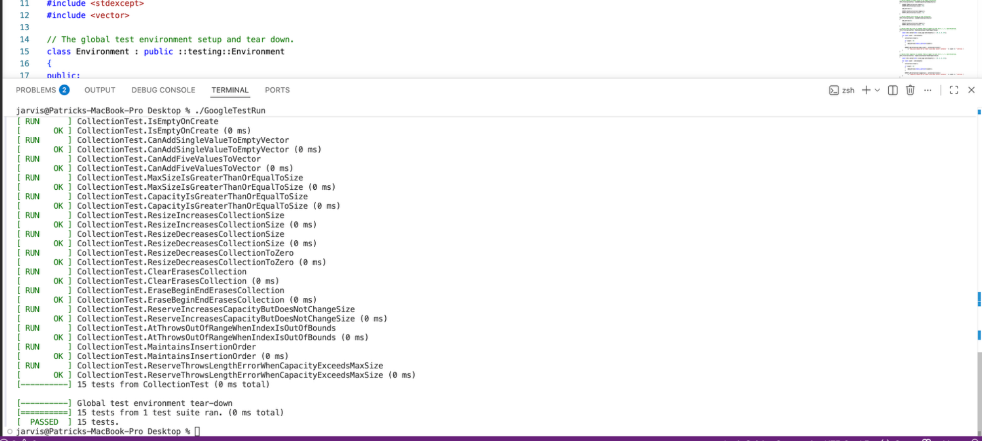
Process Summary
I completed the provided Google Test fixture by reviewing every TODO comment and turning each requirement into a named TEST_F test case. The fixture creates a fresh std::vector<int> before each test and clears it afterward, so every test runs independently. I kept the original setup pattern, commented out the intentionally failing AlwaysFail test, and added clear assertions that prove each test condition.
The implementation uses ASSERT macros when the rest of the test depends on a required setup condition, such as confirming the vector exists or contains the expected starting number of elements. It uses EXPECT macros for follow-up checks so that the test can report multiple related failures without stopping immediately. This follows normal unit testing practice because ASSERT protects the reason for the test, while EXPECT records additional proof points.
Unit Tests Implemented
Provided fixture tests kept:
- CollectionSmartPointerIsNotNull - positive test proving the smart pointer is created.
- IsEmptyOnCreate - positive test proving a new vector is empty and has size 0.
Required TODO tests completed:
- CanAddSingleValueToEmptyVector - proves one entry can be added to an empty vector.
- CanAddFiveValuesToVector - proves five entries can be added successfully.
- MaxSizeIsGreaterThanOrEqualToSize - proves max_size is at least size for 0, 1, 5, and 10 entries.
- CapacityIsGreaterThanOrEqualToSize - proves capacity is at least size for 0, 1, 5, and 10 entries.
- ResizeIncreasesCollectionSize - proves resize can increase vector size.
- ResizeDecreasesCollectionSize - proves resize can reduce vector size.
- ResizeDecreasesCollectionToZero - proves resize(0) empties the vector.
- ClearErasesCollection - proves clear removes all entries.
- EraseBeginEndErasesCollection - proves erase(begin, end) removes all entries.
- ReserveIncreasesCapacityButDoesNotChangeSize - proves reserve increases capacity without changing size.
- AtThrowsOutOfRangeWhenIndexIsOutOfBounds - negative test proving vector::at throws std::out_of_range.
Student-defined tests added:
- MaintainsInsertionOrder - positive test proving pushed values remain in insertion order.
- ReserveThrowsLengthErrorWhenCapacityExceedsMaxSize - negative test proving reserve throws std::length_error when the requested capacity exceeds max_size.
Debugging and Issues Managed
Intentional failing test: The AlwaysFail test would force the suite to fail, so I left it commented out as the starter comments suggested.
Incomplete TODO bodies: Several tests had names but no proof logic. I added setup checks, actions, and assertions to prove each condition explicitly.
Negative testing without undefined behavior: I avoided unsafe vector operations such as invalid erase iterators or back() on an empty vector because those can cause undefined behavior. Instead, I used vector::at and vector::reserve, which provide defined exception behavior.
Independent test state: Each test uses the fixture SetUp and TearDown methods so one test does not depend on data left by another test.
Naming clarity: I renamed and added test cases with descriptive names that explain the exact condition being verified.
Best Practices Used
- Used descriptive TEST_F names that communicate each test condition.
- Used ASSERT for required preconditions and EXPECT for additional result checks.
- Added inline comments for readability without over-commenting obvious C++ statements.
- Kept vector operations inside the standard library and avoided undefined behavior.
- Used the Google Test fixture pattern so setup and cleanup are consistent across tests.

